**Team Name:** ByteMe

Connor Thompson

Chandler Garthwaite

Ian Brobin

Austin Albert

Lab 7 Write-Up

1. No
2. Screenshot of our partially mapped world: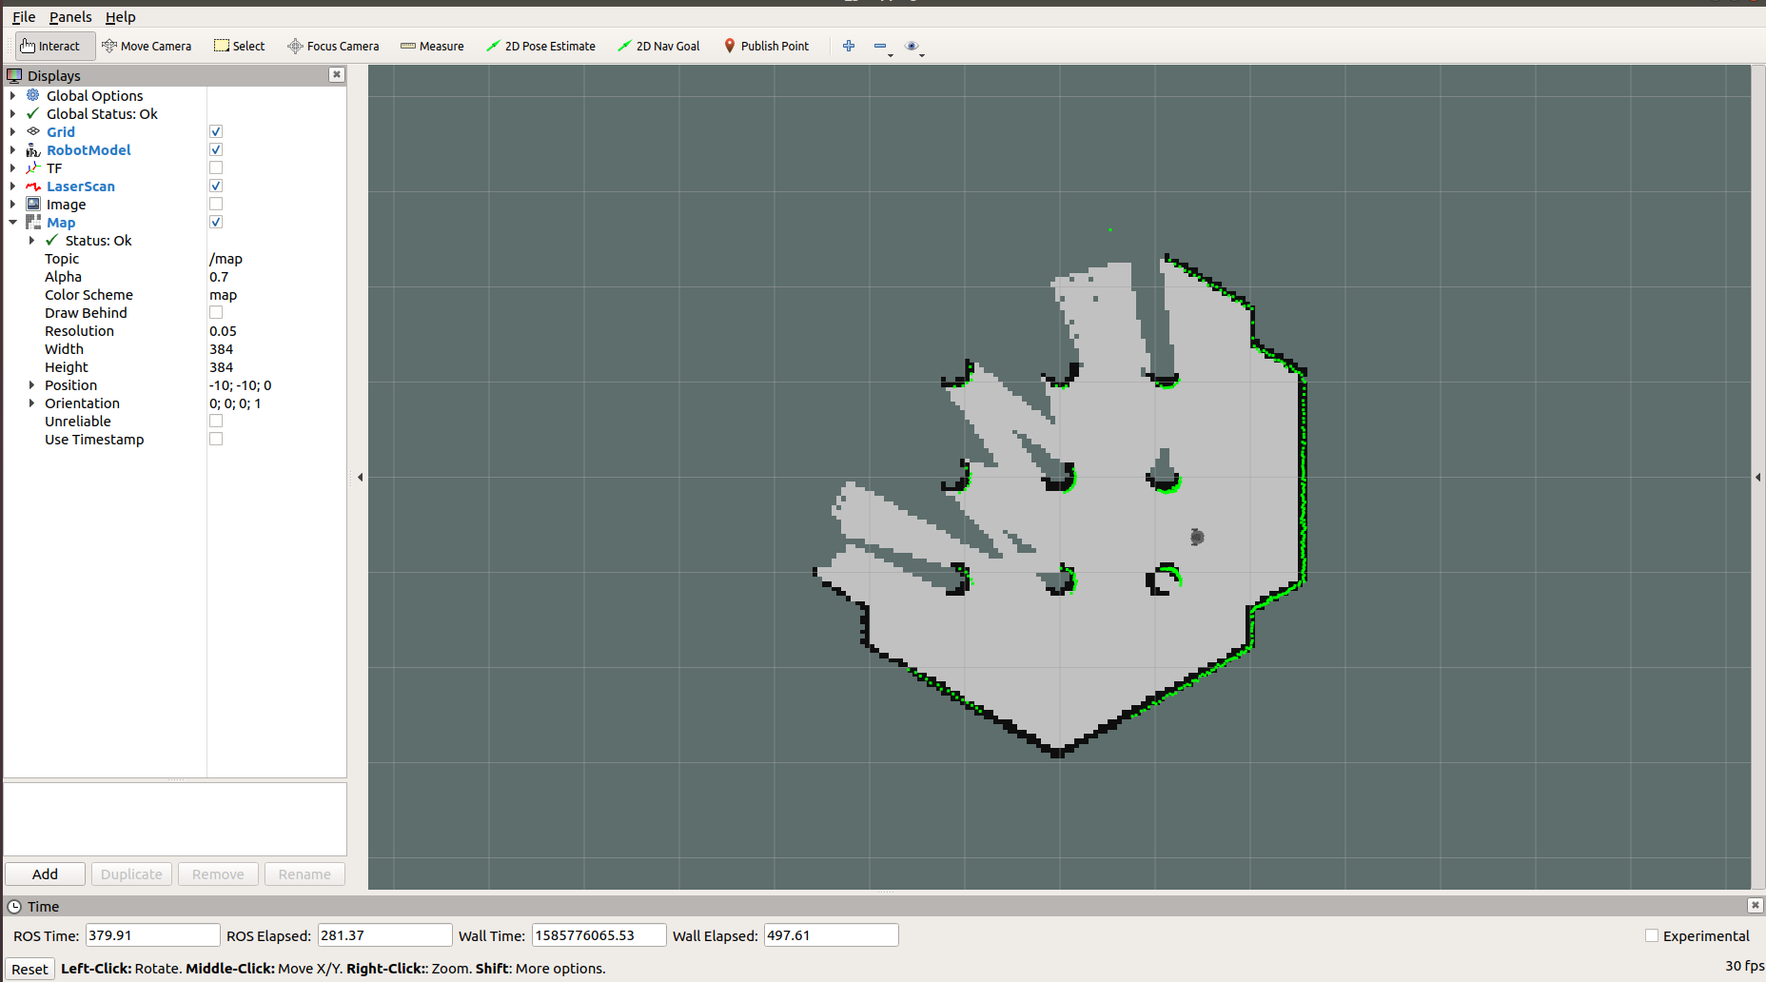
3. From our Gazebo simulator, we can see the resolution is 0.05 meters/pixel, or in other words, our resolution is 5cm/pixel. The pose of the map’s lower-left corner with respect to the world frame is [-10, -10, 0].
4. The default initial pose set in part 3.2 is (-2.0, -0.5, 0.0)
   1. When we launch turtlebot3_world.launch, the following get launched:
      1. The ROS node Gazebo_ros with the parameters we configure in the launch file (i.e. launch the turtlebot3 model, set its initial position, set the world, set the robot description, etc)
   2. When we launch turtlebot3_navigation.launch, the following get launched:
      1. Turtlebot3_remote.launch
      2. Map Server (ROS node)
      3. amcl.launch
      4. Move_base.launch
      5. And finally, RVIZ gets launched as a ROS node
   3. **Turtlebot3_world.launch:** Launches our turtlebot simulator into our gazebo world with some parameters we can configure.
   4. **Turtlebot3_navigation.launch:** Launches other things we need to begin to navigate with our turtlebot
   5. **Turtlebot3_remote.launch:** Launches a ROS node to publish the robot state to a topic.
   6. **Amcl.launch:** Contains parameters used to control mapping + environment
      1. Where to publish scan messages, how often to refresh GUI, how many particles to use in GUI, lazer range in X/Y/Z, etc…
   7. **Move_base.lanuch**: Launches a ROS node that takes in our map filenames for mapping + sets-up the robot odometry + velocity publishing.
5. A
6. No
7. We spent 3 hours working on this lab.